ULTRASONIC TESTING REPORT
Company/Client |  | NCOC N. V. |  | Project |  | ESKENE WEST KARABATAN |  | Location |  | KUT - 570
Line No/Tag No: |  | A1-5700-CS-035-3/4"-NI2.4-HC |  | Material |  | Pipe:B167- N06600;  Elbow & Tee: B366 |  | Día × Nominal Thickness |  | ¾” × 2.87mm
Procedure No: |  | QP-11-UTT-Q01 Rev 01  GOST 28702-90 |  | Calibration Block |  | Step wedge |  | Probe  S/N |  | MTD 705  n/a
 |  |  |  | Calibration block Range |  | 6,25-25 mm |  | Angle |  | 0º
Manufacturing Code |  | ASME B31.3 |  | Calibration Temp |  | +20º |  | Frequency |  | 5 MHz
 |  |  |  | Object Temp |  | +20º |  | Size |  | 3,8 mm
Acceptance Standard: |  | Acc. to the client specif. |  | Correction factors |  | n/a |  | Crystal |  | Dual
Surface condition |  | Uncoated |  | Couplant |  | UT Gel |  | Accuracy |  | ± 0,1 mm
S. No | Equipment/  Material Name |  | Manufacturer |  | Serial No |  | Calibration certificate No |  | Calibration Expiry date
 | A-scan UT |  | OLYMPUS DL-38 |  | 171421601 |  | 2113237 |  | 02-04-2019
 | Step wedge calibration block |  | NDE-TECH |  | NDE-8363 |  | 7439 |  | 09-05-2020
Job description:

- UT spot check performed on line A1-5700-CS-035-3/4"-NI2.4-HC (drawing No KE01-A1-570-MT-P-DI-1001-091).
- P&ID scheme No is KE01-A1-570-MT-R-HP-0024-008.
- Inspection performed on East, west, South, North, Top, and Bottom from external.

Notes:
N/A – not applicable.
FSH - Full Screen Height

DETAILS AND RESULTS
KE01-A1-570-MT-P-D1-1001-091

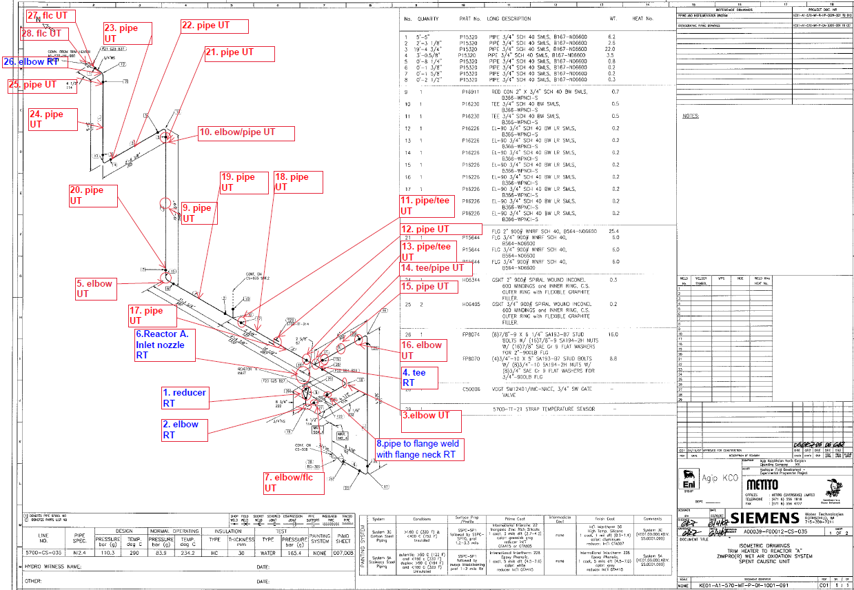

S/NO | P&ID | Isometric No | Line No | Item description | DIA(Ø), inch | Nominal thickness, mm* | East  mm | West  mm | South  mm | North  mm | Top  mm | Bottom  mm | Extrados  mm
1 | KE01-A1-570-MT-R-HP-0024-008 | KE01-A1-570-MT-P-DI-1001-091 | A1-5700-CS-035-3/4"-NI2.4-HC | Elbow – 3 | ¾ | 2.87 | - | - | - | - | 2.74 | 2.97 | 2.54
2 | KE01-A1-570-MT-R-HP-0024-008 | KE01-A1-570-MT-P-DI-1001-091 | A1-5700-CS-035-3/4"-NI2.4-HC | Elbow - 5 | ¾ | 2.87 | 2.91 | 3.01 | - | - | - | - | 2.53
3 | KE01-A1-570-MT-R-HP-0024-008 | KE01-A1-570-MT-P-DI-1001-091 | A1-5700-CS-035-3/4"-NI2.4-HC | Elbow / flc - 7 | ¾ | 2.87 | - | - | 2.74 | 2.79 | 3.60 | 2.73 | -
4 | KE01-A1-570-MT-R-HP-0024-008 | KE01-A1-570-MT-P-DI-1001-091 | A1-5700-CS-035-3/4"-NI2.4-HC | Pipe - 9 | ¾ | 2.87 | 3.17 | 3.24 | 3.01 | 3.11 | - | - | -
5 | KE01-A1-570-MT-R-HP-0024-008 | KE01-A1-570-MT-P-DI-1001-091 | A1-5700-CS-035-3/4"-NI2.4-HC | Elbow / pipe - 10 | ¾ | 2.87 | - | - | 2.79 | 2.98 | - | - | 2.54
6 | KE01-A1-570-MT-R-HP-0024-008 | KE01-A1-570-MT-P-DI-1001-091 | A1-5700-CS-035-3/4"-NI2.4-HC | Pipe / tee - 11 | ¾ | 2.87 | 3.10 | 3.08 | - | - | 3.18 | 3.17 | -
7 | KE01-A1-570-MT-R-HP-0024-008 | KE01-A1-570-MT-P-DI-1001-091 | A1-5700-CS-035-3/4"-NI2.4-HC | Pipe - 12 | ¾ | 2.87 | 3.12 | 3.12 | - | - | 3.10 | 3.06 | -
8 | KE01-A1-570-MT-R-HP-0024-008 | KE01-A1-570-MT-P-DI-1001-091 | A1-5700-CS-035-3/4"-NI2.4-HC | Pipe / tee - 13 | ¾ | 2.87 | 2.94 | 2.98 | - | - | 2.98 | 2.96 | -
9 | KE01-A1-570-MT-R-HP-0024-008 | KE01-A1-570-MT-P-DI-1001-091 | A1-5700-CS-035-3/4"-NI2.4-HC | Tee / pipe - 14 | ¾ | 2.87 | 2.98 | 3.12 | - | - | 2.74 | 2.77 | -
10 | KE01-A1-570-MT-R-HP-0024-008 | KE01-A1-570-MT-P-DI-1001-091 | A1-5700-CS-035-3/4"-NI2.4-HC | Pipe - 15 | ¾ | 2.87 | - | - | 3.28 | 3.23 | 3.25 | 3.19 | -
11 | KE01-A1-570-MT-R-HP-0024-008 | KE01-A1-570-MT-P-DI-1001-091 | A1-5700-CS-035-3/4"-NI2.4-HC | Elbow - 16 | ¾ | 2.87 | - | - | 3.37 | 3.49 | - | - | 2.99
12 | KE01-A1-570-MT-R-HP-0024-008 | KE01-A1-570-MT-P-DI-1001-091 | A1-5700-CS-035-3/4"-NI2.4-HC | Pipe - 17 | ¾ | 2.87 | 3.12 | 3.12 | - | - | 3.10 | 3.06 | -
13 | KE01-A1-570-MT-R-HP-0024-008 | KE01-A1-570-MT-P-DI-1001-091 | A1-5700-CS-035-3/4"-NI2.4-HC | Pipe - 18 | ¾ | 2.87 | 3.12 | 3.12 | - | - | 3.10 | 3.06 | -
14 | KE01-A1-570-MT-R-HP-0024-008 | KE01-A1-570-MT-P-DI-1001-091 | A1-5700-CS-035-3/4"-NI2.4-HC | Pipe - 19 | ¾ | 2.87 | 3.12 | 3.07 | - | - | 3.12 | 3.20 | -
15 | KE01-A1-570-MT-R-HP-0024-008 | KE01-A1-570-MT-P-DI-1001-091 | A1-5700-CS-035-3/4"-NI2.4-HC | Pipe - 20 | ¾ | 2.87 | 3.06 | 3.01 | 3.11 | 3.05 | - | - | -
16 | KE01-A1-570-MT-R-HP-0024-008 | KE01-A1-570-MT-P-DI-1001-091 | A1-5700-CS-035-3/4"-NI2.4-HC | Pipe - 21 | ¾ | 2.87 | 2.98 | 3.04 | 2.95 | 2.97 | - | - | -
17 | KE01-A1-570-MT-R-HP-0024-008 | KE01-A1-570-MT-P-DI-1001-091 | A1-5700-CS-035-3/4"-NI2.4-HC | Pipe - 22 | ¾ | 2.87 | - | - | 3.11 | 3.10 | 3.10 | 3.13 | -
18 | KE01-A1-570-MT-R-HP-0024-008 | KE01-A1-570-MT-P-DI-1001-091 | A1-5700-CS-035-3/4"-NI2.4-HC | Pipe - 23 | ¾ | 2.87 | - | - | 3.04 | 3.06 | 3.12 | 3.04 | -
19 | KE01-A1-570-MT-R-HP-0024-008 | KE01-A1-570-MT-P-DI-1001-091 | A1-5700-CS-035-3/4"-NI2.4-HC | Pipe - 24 | ¾ | 2.87 | 3.10 | 3.08 | 3.10 | 3.16 | - | - | -
20 | KE01-A1-570-MT-R-HP-0024-008 | KE01-A1-570-MT-P-DI-1001-091 | A1-5700-CS-035-3/4"-NI2.4-HC | Pipe - 25 | ¾ | 2.87 | 3.07 | 3.09 | 2.90 | 2.98 | - | - | -
21 | KE01-A1-570-MT-R-HP-0024-008 | KE01-A1-570-MT-P-DI-1001-091 | A1-5700-CS-035-3/4"-NI2.4-HC | Flange - 27 | ¾ | 2.87 | 2.85 | 2.95 | - | - | 2.71 | - | -
22 | KE01-A1-570-MT-R-HP-0024-008 | KE01-A1-570-MT-P-DI-1001-091 | A1-5700-CS-035-3/4"-NI2.4-HC | Flange - 28 | ¾ | 2.87 | 2.91 | 2.88 | - | - | 2.86 | 2.98 | -

*according to ASME B36.10-B36.19 schedule 40

Examined by  UT L II cert. No C/625  expiry date 07.07.2023 | Name: Sudhagar Subramanian | Signature: ........................................... | Date: 03.10.2018
Approved by  UT L III cert. No 1A123/15  expiry date 29.02.2020 | Name: Shundryk Ihar | Signature: ........................................... | Date: 03.10.2018
Client Representative: | Name: ………………………………… | Signature: ........................................... | Date: …………………………

